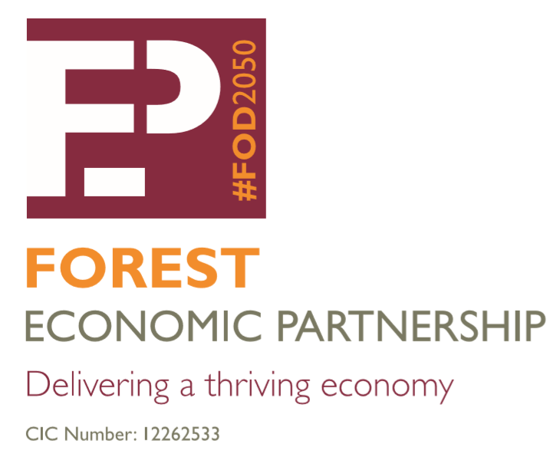

Forest Economic Partnership

(FEP)

Vision
In 2050 the Forest of Dean is an attractive, vibrant and dynamic destination to live, work and do business.

Mission
To deliver a thriving economy in the Forest of Dean by connecting business, education, public sector, people, ideas, and resources.

Terms of Reference 2024

- Create a bold vision to deliver sustainable economic growth in the Forest to 2050.
- Contribute towards informing countywide plan/policy making and to provide evidence for funding application work.
- Contribute to other strategic and local strategy work that aligns with FEP vision.
- Implement project activity to deliver the FEP vision.
- Prioritise support for specific economic sectors in the Forest eg. Advanced engineering, manufacturing, transport, construction, and tourism.
- Connect businesses with business networks, such as Gloucestershire Growth Hub Network.
- Connect businesses with Forest of Dean District’s High Schools/Academies, Gloucestershire College & Hartpury College & University (and other training providers) to their employer training programmes and apprenticeship schemes.
- Agree a Communication Strategy with key messages to support a proactive approach and to help plan FEP and stakeholder resources for all press/media/web/social media communications.
- Agree and monitor baseline economic indicators.

Governance
FEP is a Community Interest Company. This consists of an Executive Board that has a mix of Executive and Non-Executive roles to guide the work of FEP. The Board will report to the Stakeholder Group which as an open forum will remain as the decision-making body. The three themed Sub-Groups which meet in closed session will report to the Stakeholder Group. The Stakeholder Group as the decision making body will continue to meet on a quarterly basis, or more frequently if there are urgent matters to be discussed. The Sub-Groups to meet as and when required and to report back to the quarterly Stakeholder Group meeting.

Chair/Vice-Chair
It is recommended that the following people retain their Chair and Vice-Chair roles in 2024:

- Chair – Neill Ricketts
- Vice-Chair – Cllr Johnathan Lane

Sub-Groups

Each Sub-Group to nominate a lead member to be responsible for coordinating meetings, communicating with other members and providing feedback to the Partnership. In 2024 the following Sub-Groups are:

- Education and Skills
- Transport, Infrastructure, Bridges & Borders (inactive)
- Digital Connectivity
- Climate Action

Stakeholder Meetings

Quoracy – 4 members as a minimum are needed to hold a quorate meeting.
Decision making responsibilities: | - Ability for Vice-Chair to stand-in Chair should the Chair not be able to attend the meeting.  - Agree the Forest Economic Partnership vision & mission.  - Agree content of contributions to any other draft Strategy document that aligns with FEP vision.  - Agree scope & content for the Communication Strategy, 2024 Key Messages and any marketing campaigns.  - Approve expenditure against secured grant or sponsorship funding.  - Agree to share economic baseline data.
Voting procedures: | - Decisions of the Forest Economic Partnership Stakeholder Group are intended to be made by consensus. Where consensus cannot be reached after a reasonable amount of discussion (which shall be determined at the Chair’s discretion) then a vote may be requested by any Member to resolve the matter.  - Each Stakeholder Group Member shall have one vote (one vote per organisation).  - If a vote is held, it shall be carried by a majority of those present and entitled to vote.  - Voting shall be by show of hands.  - If there is a deadlock, then the Chair will have a casting vote.  - Urgent matters to be agreed by email, by exception and with unanimity.

Attendance: | For meetings with fewer than four members (including the Chair) the Chair will need to consider the benefits of continuing the meeting.
Meeting notes & action tracker: | FoDDC to prepare & circulate
Circulation of notes & action tracker: | Forest Economic Partnership Board members
Frequency of meetings | Meetings will be held 4 times a year or as requested by the chair.
Meeting location: | Various venues
Meeting times: | 1pm June 19th  1pm September 18th  1pm December 18th
Status of meetings: | Stakeholder Group - Open  Sub-Group – Closed

Date: 20.03.24
Review Date: 20.03.2025

