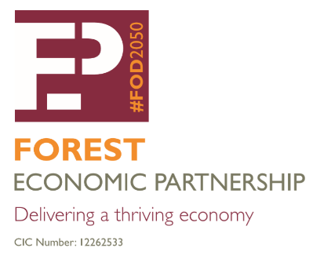
Celebrating Success – Recruiting a marketing & communication specialist
CONSULTANCY BRIEF
- Client
Forest Economic Partnership. A Community Interest Company registered in October 2019.
- Fixed term contract
- 12 month fixed term contract - 09 Feb 2024 to 09 Feb 2025
- Face-to-face interview panel date – 07 Feb 2024
- Contractor selection and appointment confirmation date – 09 Feb 2024
- Online client/contractor inception meeting – tbc
- Online monthly progress meetings - tbc

- Budget
Budget range £6,500 - 8,000
- Contract specification
Specialist marketing and communications input is required to prepare a FEP Communication Plan 2024-2026, to celebrate the success and innovation demonstrated by Forest of Dean businesses. The FEP Communication Plan will aim to connect with more FoD businesses and social enterprises to:
• increase the awareness of FEP lobbying work, research and sub-group activities.
• design & deliver a new FEP Business Award Scheme to celebrate INNOVATION in 2024.
• set out a sponsorship protocol to support FEP core costs and project activity.
• increase active participation from FEP stakeholders in FEP activity.

- Contract key deliverables
The FEP Communication Plan will need to identify key deliverables or critical success factors that will be monitored by FEP Secretariat and reported to FEP Stakeholder Meetings and FEP Board.

Deliverable | Target | Deadline
Prepare & finalise a Communication Plan to set out all existing and new activity planned for 2024-25 | Draft document to be presented to FEP Board meeting on 13 March 2024 | Draft 06 Mar 2024  Final 31 Mar 2024
Communication Plan to increase FEP stakeholder membership | 366 stakeholder members - 25% increase on Dec 2023 baseline of 293 members | 28 Feb 2025
Communication Plan to increase FEP stakeholder quarterly meeting attendance | Minimum of 40 attendees per meeting – 25% increase on Dec 23 attendance of 32 | 28 Feb 2025
Communication Plan to measure social media visits, following, post impressions on: Facebook, LinkedIn & Instagram. | Target 30% annual increase on Dec 23 followers  Instagram – 238 followers  Twitter – 410 followers  Facebook – 240 followers and 200 likes  LinkedIn – 160 followers | 28 Feb 2024
Communication Plan to include diversity, equality and inclusion metrics. | Collate evidence of demographic representation s in ads, images, PR and video | 28 Feb 2025
Prepare a proposal for grant funding / company sponsorship | Identify a list of potential sponsorship partners, design sponsorship protocol & information pack | 30 Mar 2024
Prepare a proposal for a new FEP Business Award scheme | Create project plan, identify resources, award ceremony format & the type of award to be presented | 12 June 2024
Prepare a new FEP Top 100 Business Directory – digital format | Include a minimum of 10 businesses from 10 of FoD’s largest employment sectors | 11 Sep 2024
Design & print a hard copy folder to hold information to support 2025 business visits | Print run approx. 1,000 tbc | 22 Nov 2024

Client points of contact
Ian Mean MBE – FEP Director ian.mean@businesswest.co.uk M. 07718 152164

Wendy Jackson – FEP Director wendy.jackson@fdean.gov.uk T. 01594 812645

